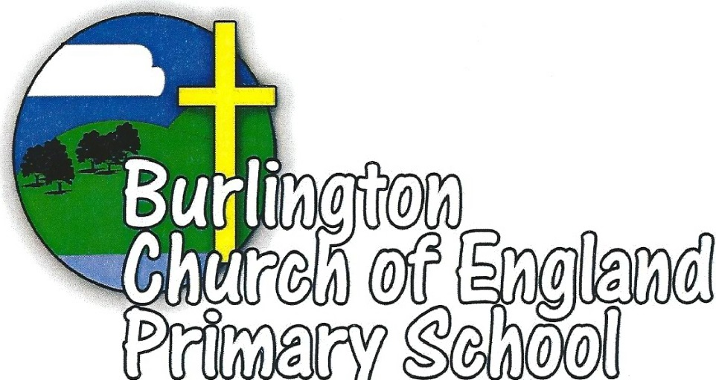

Behaviour and Discipline Policy

Status of Policy
Policy created | September 2015
Policy reviewed | April 2017
Agreed by Staff | May 2017
Agreed by Governors | May 2017
Review | July 2019

Burlington CE School Behaviour and Discipline Policy.

Introduction
Within a school it is important that children, teachers and parents develop relationships that will enhance the educational experiences of the pupils. To do this successfully, it is essential that we have an agreed policy for managing pupil discipline and behaviour. It must be fair for all pupils and enables everyone to work together with our shared values in a positive and coherent manner.

Guidelines for Staff
All staff are expected to follow the guidelines set out in this policy. This includes lunchtime supervisors, teaching assistants, teachers, supply staff, office staff and senior staff.

Core principles
- We believe that when learning is engaging and exciting, this has a positive effect on children’s behaviour
- Good relationships are essential and the first strategy in securing good behaviour
- We believe that rights come with choices and consequences
- We recognise that there are strong links between good self-esteem and achievement
- All children need a range of strategies to manage their day successfully
- Staff and older children play an important role in modelling expectations and demonstrating our values in their everyday practice
- We agree charters which must be clear, fair, understood by all and consistently applied
- Good pupil behaviours come about from a joint approach between school and home

We work within the framework of the 42 articles stated in the UN Convention on the Rights of the Child.
These support our Values approach and we focus on ten articles which are most relevant to the Burlington CE Primary School community.
Article 2: The Convention is for everyone under 18, whatever their race, religion, abilities, whatever they think or say, and whatever type of family they come from.
Article 12: Children have the right to say what they think should happen when adults are making decisions that affect them, and to be listened to.
Article 28: Children have a right to an education. Discipline in schools should respect children’s human dignity. Primary education should be free. Wealthy countries should help poorer countries achieve this.
Article 29: Education should develop each child’s personality and talents to the full. It should encourage children to respect their parents, and their own and other cultures and the environment.
Article 31: All children have the right to relax and play, and to join in a wide range of activities.

We have a NO SHOUTING POLICY and in your relationships with children you will:
- Respond positively and calmly to children and their ideas
- Set high standards in all areas of school life
- Make each child feel that they have the ability to succeed
- Make it clear that each child has a responsibility for his/her own actions
- Apply class charters firmly and fairly, praising appropriately
- Apply rewards and sanction in all aspects of school life e.g. behaviour, work quality, effort
- Deal with poor behaviour wherever it happens, we are all responsible
- Avoid nagging, punishing the whole class, negatively labelling children, shouting or using sarcasm

We know that behaviour is good around the school because
- Children know and understand their rights and respect those of others
- There is purposeful learning atmosphere in the classroom and halls
- Movement around the school is calm, orderly, quiet and safe
- Children do what they are asked to do, on the first time of asking by an adult
- There are few referrals of poor behaviour to class teachers following lunchtimes and playtimes
- There is evidence of good independent and collaborative skills both in and outside the school
- Respect is shown to other children and adults
- Adults and children demonstrate our values everyday

Promoting good behaviour
All staff use the language of Rights and Respect to support our pupils in understanding of the rights of all children and all members of our school community. At the start of each school year a new class charter is negotiated and agreed with the children. This is displayed prominently and referred to on a regular basis to support learning attitudes and positive behaviours.
PSHE and Circle Time are used to support children in learning how to communicate their feelings, set themselves goals and work towards them, interact successfully with others, resolve conflicts peaceably, control their anger and negotiate their way through the many complex relationships in their lives.
All staff work toward ensuring that all children move around the school in a safe and orderly manner.

Supporting children with behavioural difficulties
All children should be encouraged to maintain the school behaviour policy in all areas of their school life. Where a child finds this genuinely difficult he/she should be supported in a way that is appropriate to their age, ability and need.

The role of parents and guardians
Sign the Home School Agreement. This outlines the responsibilities of the parent and the school; including those around behaviour and attendance.
The school will work hard to support children who experience difficulty. It is assumed that all parents and carers will support the school in expecting the highest levels of behaviour from their child and abiding by the school Behaviour Policy.

The role of the child
Pupils are expected to help formulate and to follow all the school and class charters. School charters and rules are developed with the children using the language of rights and responsibilities. Everybody at Burlington is expected to show respect and good manners and be polite at all times. Pupils are taught to have a clear understanding that all behaviours have consequences in terms of rewards and sanctions and that behaviour is about making choices.

Consequences
It is very important to stress the positive aspect of children’s behaviour and to be clear that when things go wrong it is the behaviour we do not like, not the child. Sanctions are used (Appendix 2).

Rewards
A range of rewards are used to recognise achievement and encourage further success. In addition to following these systems we expect staff to use:
- Verbal praise and non-verbal signals (smiling, thumbs up etc.)
- Written messages on children’s work
- Phone calls and letters to parents
- Articles in the school newsletter or other publications
- Public praise in assembly

Rewards are given for academic progress, sporting success, effort, improvements in behaviour and attitudes, and for actions taken that contribute to the wellbeing of others, reflecting our Rights Respecting approach and our core values. Parents are kept informed through informal conversations with the teacher, golden postcard, special achievements child’s name in the newsletters.
Staff actively promote and reward good learning attitudes. For example: perseverance, collaboration, good listening skills, endeavour and self-review.
Individual reward charts are used with a minority of children who need further support in managing their school day. These charts are shared with parents and result in an agreed reward that is used to motivate a child to change their behaviour by making the right choices during the school day.

Progressive Sanctions
The school deploys a number of sanctions that progress in severity to enforce school expectations and reinforce boundaries. Poor behaviour is recorded and monitored closely and we use the language that reflects a pupil’s choice of behaviour. Where poor behaviour continues, the child will move through a planned behavioural ladder (Appendix 2) that reflects the increasing seriousness of the behaviour. Sanctions range from a simple reprimand, to (very exceptional circumstances) an exclusion from the school.

Restorative justice
Restorative justice involves all parties talking about an incident, often together. It links actions with consequences, and requires time to provide adequate opportunity for children to articulate their thinking and reasoning. A restorative approach to conflict asks four key questions.
1. What has happened?
2. How do you feel about it?
3. What would you like to see happen?
4. What are we going to do about it – today, tomorrow?

All staff recognise the power of changing behaviours through this tier of questions which increases awareness of personal responsibility.

Bullying
Bullying can be defined as a behaviour by an individual or group, usually repeated over time, that intentionally hurts an individual or group either physically or emotionally. The school does not accept bullying of any kind whether it is face to face, using the internet or a phone.
All staff are vigilant, particularly in the playground and when children are coming into school and leaving school. Name calling and play fighting are unacceptable behaviours as they can lead to instances of bullying behaviour. There are more details in the school’s Anti Bullying Policy.

Prejudice behaviour
Prejudice behaviour is not accepted by staff or students. Examples of prejudice behaviour include incidents involving race, religion or belief, gender, SEN and disability and sexual orientation. Sufferers of discrimination and harassment will be aided and supported whilst offenders will be counselled and supported to understand why their actions are unacceptable and not in keeping with the aims of a Rights Respecting school. These incidents are reported internally via a form available from the School Business Manager and anonymously to the governing body and the local authority. Co-operation between school and home is considered vital in this area if the wellbeing of all our pupils is to be maintained. There are more details in the school’s Equality Policy.

Use of Force to Control or Restrain Pupils
All staff are aware of the 2011 DfE interim Guidance on the use of reasonable force. Staff only intervene physically to restrain children, prevent injury to a child, or if a child is in danger of hurting him/herself. Any actions taken are in line with current government guidelines and are recorded.

References
- Behaviour and Discipline in Schools - A Guide for Head Teachers and School Staff DfE 2014
- Behaviour and Discipline in Schools - Guidance for Governing Bodies DfE 2013
- Use of Reasonable Force - Advice for School Leaders, Staff and Governing Bodies 2011
- Keeping Children Safe in Education – Statutory Guidance for Schools and Colleges DfE 2015

This policy should be read in conjunction with other school policies and guidelines including our Anti Bullying Policy, E Safety, R.E., PSHE, Safeguarding, and our Teaching & Learning Policies.

Appendix 1
Wet Playtimes Guidance
Each class need to have clear guidance for what is acceptable and what is not acceptable during wet playtimes and lunchtimes.
Each class except Year 6 are allocated a wet playtime monitor (peer mediators) who will support the children in making good choices and playing games
All children need to undertake settled activities. If the laptops and IWB can be used (class teachers decision) then there must be a protocol for their use understood by all.
Each class needs to have a store of appropriate games, drawing paper, comics etc.

Appendix 2
Boundaries and sanctions to be used to improve unsatisfactory behaviour
 | Behaviour examples | Comments/strategies | Sanctions
Class teacher | Low level disruption  - Chatting when you’ve been asked to work silently or when an adult is speaking  - Fidgeting when being taught  - Flicking pencils or rulers  - Inappropriate laughing or singing  - Annoying others to get a reaction including name calling  - Not working at your full capacity  - Getting out of your seat at inappropriate times  - Calling out | - Catch pupil being good & praise & ignoring some inappropriate behaviours  - Build positive relationships with children that have the potential to pose a challenge  - Expectations reinforced  - Stop & wait, frowns, eye contact & other non-verbal approaches  - Time frame agreed for desired improvement.  - Not recorded  - Minimum use of language to correct behaviour in front of class  - Break the cycle – redirect | - Reminder of classroom charter  - Warning and name on board  - Teacher to discuss behaviour 1:1  - Time out in another class at a time out table (5/10 min) – work is sent with the child.  - Class teacher to speak parent at the end of the school day or by telephone after school
Senior Leader | Serious  - A child has reached 4 (above) and the low level disruption continues  - Severe arguing back or disrespecting adults (this may include swearing at an adult)  - Swearing  - Throwing small objects  - Damaging pupil/ school property  - Leaving class without permission  - Bullying  - Stealing  - Severe arguing with another child – this may include pushing | - Catch pupil being good & praise  - Class teacher make an effort to build a relationship with the child e.g. eating lunch with the child  - Home/school log set up by Class teacher  - A restorative approach is used. | - Pupil sent to Senior Leader. Senior Leader and Class Teacher decide the length of time out that the child needs.  - Class teacher to speak parent at the end of the school day or by telephone after school
Head  teacher | Very Serious  - Fighting  - Bullying  - Prejudice (including racism or sexism)  - Extreme violence towards adults and children  - Use or display of potential weapons  - Fighting, causing intentional harm  - Leaving the school site without permission  - Persistent lack of will shown to change behaviour  - Throwing large objects  - Little remorse shown | - Catch pupil being good & praise  - HT informed/involved  - Possible involvement of external agencies  - Pastoral Care Plan set up  - Involvement of external agencies | Internal exclusion with HT  Lunchtime Detention- Must be supervised in classroom or office by an adult  Internal exclusion letter sent home by HT

